Bonnington Symbol System
City of Edinburgh Council

Symbol resource 2008
including relevant British Standard symbols from BS 8501


Activities
Catering
College
Environments
Health
Home
People
Self development

art
leisure
shopping
sport




The Resource
This resource has been created as a series of word documents which may be printed out to use as a visual reference and index.

Copy and Paste/Instructions
To reproduce an image:
- Single click on the image ensuring it is selected
- Select Copy from the Edit menu (or use keyboard shortcut Ctrl+C)
- Open the document you wish to place the image in (e.g. word document)
- Select Paste from the Edit menu (or use keyboard shortcut Ctrl+V)

Images may be resized by dragging in or out from a corner, images may be resized up to A4 without any loss of quality.

Images may be placed in tables or text boxes.

If you have any difficulty using any of the images please contact BSS using the contact details below.

Acknowledgement British Standards: Permission to reproduce extracts from the BS 8501:2002 is granted by BSI. The British Standards can be obtained from BSI Customer Services, 389 Chiswick High Road, London W4 4AL. Tel +44 (0)20 8996 9001

Acknowledgement BSS Edinburgh Council: Permission to reproduce BSS symbols is granted by The City of Edinburgh Council Health and Social Care; however reproduction of any part of the CD ROM in any form is not permitted.

Disclaimer: The City of Edinburgh Council cannot accept any responsibility for damage caused to your computer or data whilst using this CD.

Contact information: Gordon Fraser, Performance Review Manager. The City Of Edinburgh, Health and Social Care, Waverley Court, 4 Market Street Tel: +44 (0)131 553 8266
www.edinburgh.gov.uk/internet/social_care/CEC_learning_disability

 |  | 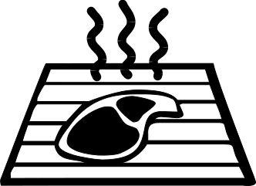
Aromatherapy  1000 | Art  1001 | Barbeque  1002
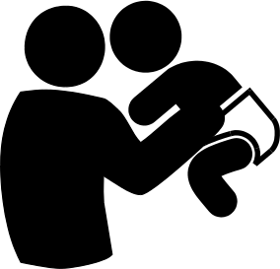 | 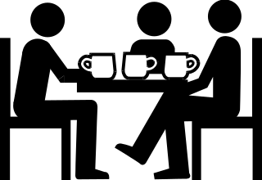 | 
Childcare  1003 | Coffee break  1004 | Communication  1005
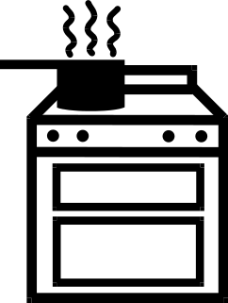 |  | 
Cooking  1006 | Craft #1  1007 | Craft #2  1008
 | 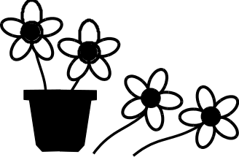 | 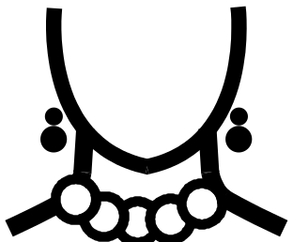
Craft-film making  1009 | Craft-floristry  1010 | Craft-jewellery making  1011
Bonnington Symbol System
www.edinburgh.gov.uk
 |  | 
Craft-knitting  1012 | Craft-photography  1013 | Craft-digital photography  1014
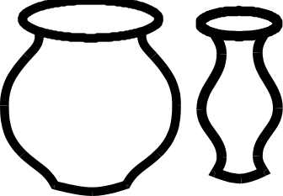 |  | 
Craft-pottery  1015 | Craft-printmaking  1016 | Craft-sewing  1017
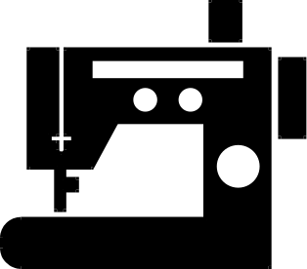 | 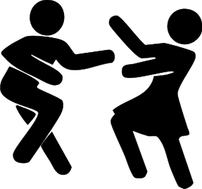 | 
Craft-sewing using machine  1018 | Dance  1019 | Dance-country dancing  1020
 |  | 
Day centre  1021  Bonnington Symbol System  www.edinburgh.gov.uk | DIY  1022 | DVD watching  1023
 |  | 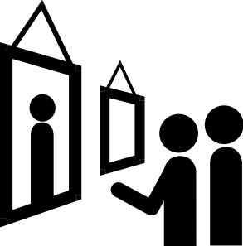
Gardening  1024 | Go on holiday  1025 | Going out-art gallery  BS 8501 8003
 |  | 
Going out-beach trip  BS 8501 8037 | Going out-cafe  BS 8501 8067 | Going out-cinema  BS 8501 8002
 | 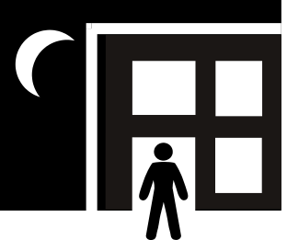 | 
Going out-community centre  BS 8501 8005 | Going out-evening  1026 | Going out-farm visit  BS 8501 8023
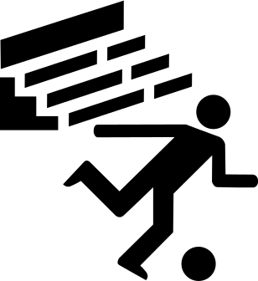 |  | 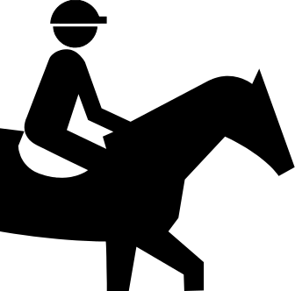
Going out-football match  BS 8501 9071  Bonnington Symbol System  www.edinburgh.gov.uk | Going out-garden visit  BS 8501 8034 | Going out-horse show  BS 8501 9031
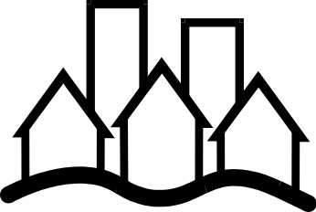 | 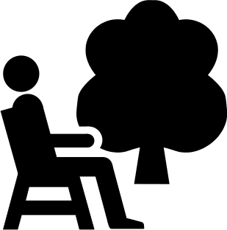 | 
Going out-out and about  1027 | Going out - public park  BS 8501 8040 | Going out - pub  1028
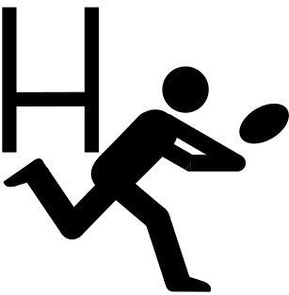 |  | 
Going out -rugby game  BS 8501 9047 | Going out-theatre  BS 8501 8001 | Going out -house of architectural interest  BS 8501 8046
 |  | 
Going out–wildfowl reserve  BS 8501 8029 | Going out-library  BS 8501 8004 | Going out- zoo  BS 8501 8019
 |  | 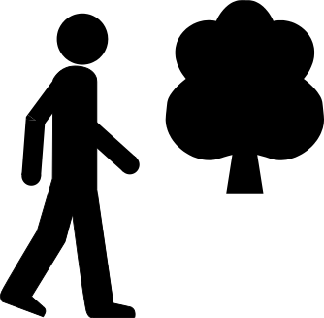
Going out-religious building  BS 8501 8047 | Going out - walk  BS 8501 4122 | Going out- walk in country  1029
Bonnington Symbol System
www.edinburgh.gov.uk

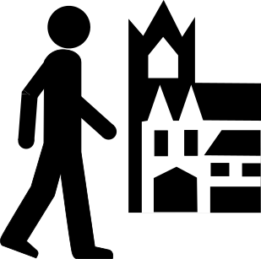 |  | 
Going out-walk in town  BS 8501 8035 | Group-batik  1030 | Group-beauty  1031
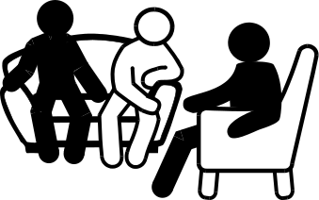 |  | 
Group-comfy group  1032 | Group-conservation  BS 8501 5020 | Group-drama  BS 8501 8001
 |  | 
Group-feeling good  1033 | Group-healthy eating  1034 | Group-healthy living  1035
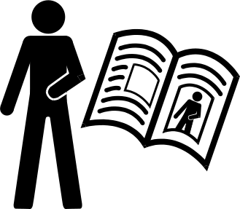 |  | 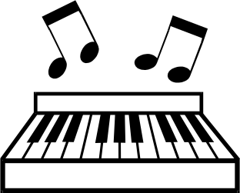
Group-life stories  1036 | Group-men’s group  1037 | Group-music  1038
Bonnington Symbol System
www.edinburgh.gov.uk

 | 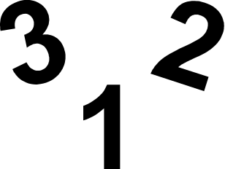 | 
Group-nature  1039 | Group-numeracy  1040 | Group-reminiscence  1041
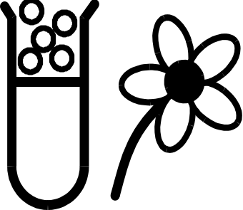 |  | 
Group-science  1042 | Group-scotland  1043 | Group-weight loss  1044
 |  | 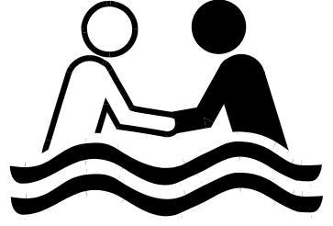
Group-woman’s group  1045 | Hill walking group  1046 | Hydrotherapy  1047
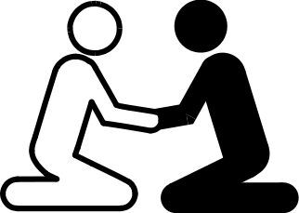 |  | 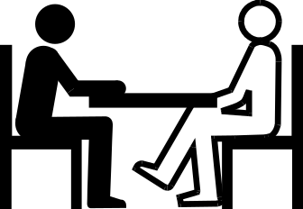
Interactive communication  1048 | Library books on tape  1049 | Meeting to discuss things  1050
Bonnington Symbol System
www.edinburgh.gov.uk

 | 
Music-listening to CD  1051 | Music-listening to tapes  1052 | Music-making music  1053
 |  | 
Music-playing guitar  1054 | Music-singing  1055 | Playing-beetle  1056
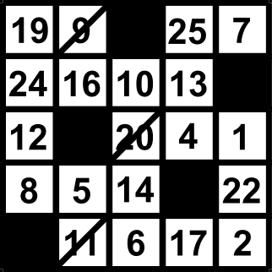 | 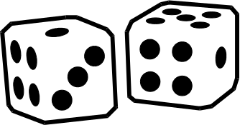 | 
Playing-bingo  1057 | Playing-board game  1058 | Playing-computer game  1059
 | 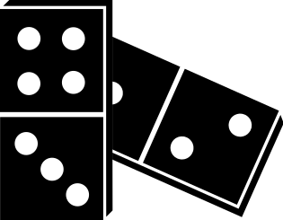 | 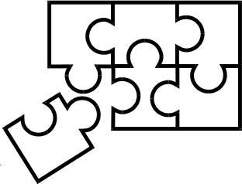
Playing-darts  BS 8501 9016 | Playing-dominoes  1060 | Playing-jigsaws  1061
Bonnington Symbol System
www.edinburgh.gov.uk

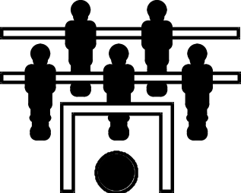 | 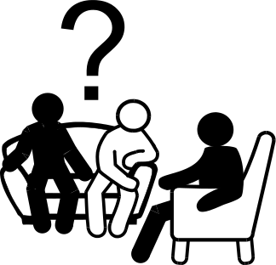 | 
Playing-table football  1062 | Quiz  1063 | Reading  1064
 |  | 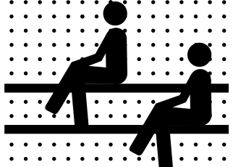
Reading the newspaper  1065 | Relaxation  1066 | Sauna  1067
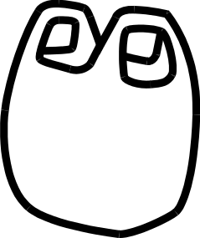 |  | 
Shopping  1068 | Signing  1069 | Symbols  1070
 | 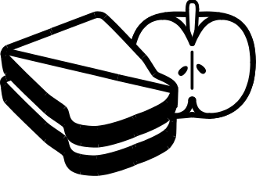 | 
Taking a bath  BS 8501 5014 | Taking a packed lunch  1071 | Taking part-Duke of Edinburgh Scheme
Bonnington Symbol System
www.edinburgh.gov.uk

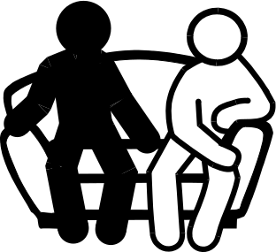 |  | 
Talking informally  1072 | Telephone  BS 8501 6003 | Television  1073
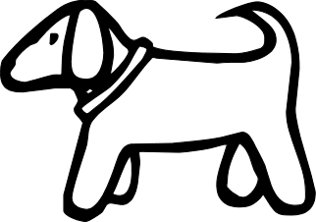 |  | 
Therapet  1074 | Transport-bus  1075 | Transport-car  1076
 |  | 
Transport-minibus  1077 | Transport-public transport #1  1078 | Transport-public transport #2  1079
 |  | 
Transport-taxi  BS 8501 7007 | Using E-mail  1080 | Using pethna equipment  1081
Bonnington Symbol System
www.edinburgh.gov.uk

 |  | 
Using the computer  1082 | Using the internet  1083 | Using video camera  1084
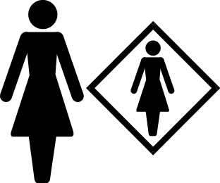 |  | 
Women’s rights  1085 | Woodwork  1086 | Work  1087
 | 
Work support  1088 | Writing  1089

Bonnington Symbol System
www.edinburgh.gov.uk

